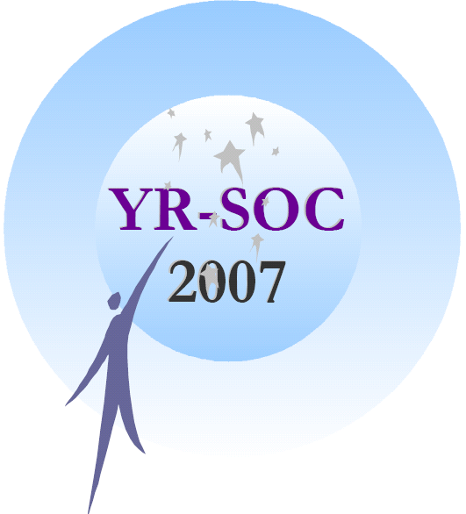 | Final Call for Papers, Call for Posters and Participation  YR-SOC 2007  2nd European Young Researchers Workshop on  Service Oriented Computing  June 11-12, 2007  University of Leicester, Leicester, UK  http://www.cs.le.ac.uk/events/yrsoc2007/

Introduction:

Following the success of the first workshop in 2005, the University of Leicester is pleased to host the 2nd European Young Researchers Workshop on Service Oriented Computing (co-organised with De Montfort University). This 2-day workshop is designed to bring together PhD students, young researchers working in the industry and those who completed their doctoral studies within the past few years. Attendance
at the workshop is open to all. The aim of the workshop is to build a reputable and respectable forum for young researchers with inputs from industry practitioners. The core objectives are to exchange information regarding advancements in the state of the art and practice of SOC, as well as to identify the emerging research topics and define the future trends in this domain.

Keynote Speakers:

- Mark Little (JBoss, UK)

- Steve Ross-Talbot (Pi4tech, UK)

- Martin Wirsing (Ludwig-Maximilians-Universität München, Germany)

Scope:

Service oriented computing is more than just ideas related to those services: in particular it is a chance of bringing together the business/user domain and the services domain. The word 'service' encompasses web services, semantic web services, grid services and e-services.

Topics of interest include, but are not limited to, the following:
- Mathematical foundations of SOC
- Data management issues in SOC
- Frameworks for building SOC applications
- Composite SOC creation and enabling infrastructures (e.g., workflow technology)
- SOC composition, orchestration, and choreography
- SOC modelling & design
- Semantic Web, ontologies, and SOC
- Agents and SOC
- Dynamic invocation mechanisms for SOC
- Contractual issues between provider and consumer of SOC
- Version management in SOC
- Customization of SOC
- SOC architecture
- SOC negotiation & agreement
- SOC discovery & selection
- UDDI and SOAP enhancements
- SOC and process management
- Trust, security & privacy in SOC
- Scalability and performance of SOC
- SOC standards and technologies
- Automatic computing for SOC infrastructure
- Wireless web, mobility, and SOC
- SOC based Grid Computing and peer to peer computing
- SOC based applications for e-commerce
- Quality of service for SOC
- Multimedia applications using SOC
- Economics and pricing models of utility computing and SOC
- Resource management of SOC
- Solution management for SOC
- Adoption of SOC by organizations
- Case studies on SOC based applications
- Analysis, testing, and verification of Services
- Context aware services
- Business modelling for services

Submission Information:

YR-SOC presentations will be selected according to originality, significance, and general interest. Selections will be on the basis of submitted 6-page concise papers. The workshop proceedings with the accepted papers will be available at the workshop. After the workshop, the author(s) of each presentation will be invited to submit a full 10-15 page paper on the same topic. They will also be asked to write (anonymous) reviews of papers submitted by other authors on related topics; further reviewing, and the final selection of papers, will be carried out by the organisers. Contributions of a high quality will be published in the proceedings (a suitable publisher will be found).

Papers must be written in English and submitted in PDF form. Papers should be no longer than 6 sides of A4, formatted in LNCS style. Author instructions may be found at http://www.springer.com/uk/home/computer/lncs?SGWID=3-164-7-72376-0.

Papers and posters may be submitted at http://www.cs.le.ac.uk/events/yrsoc2007/Submission.html.

IMPORTANT DATES (all in 2007)

Deadline for paper submissions: 16 March
Author notification: 27 April
Deadline for poster submissions: 11 May
Final paper version due: 18 May
Poster notification: 1 June
Workshop: 11-12 June

Organisation

PC Chairs
Stephen Gorton (University of Leicester)
Monika Solanki (De Montfort University)
Stephan Reiff-Marganiec (University of Leicester)

Steering Committee
Barry Norton (Open University, UK)
Monika Solanki (De Montfort University)
Stephan Reiff-Marganiec (University of Leicester)

Programme Committee
Roberto Bruni (University of Pisa, Italy)
Christoph Bussler (CISCO Systems Inc., US)
Antonio Cau (De Montfort University, UK)
Schahram Dustdar (Technical University of Vienna, Austria)
David Edmond (Queensland University of Technology, Australia)
Dieter Fensel (DERI Innsbruck, Austria)
Gianluigi Ferrari (University of Pisa, Italy)
Reiko Heckel (University of Leicester, UK)
Frank Leymann (University of Stuttgart, Germany)
Aad van Moorsel (University of Newcastle, UK)
Arun Mukhija (University College London, UK)
Barry Norton (Open University, UK)
Mike Papazoglou (University of Tilburg, Netherlands)
Stefan Tai (IBM Research, US)
Emilio Tuosto (University of Leicester, UK)
Kenneth Turner (University of Stirling, UK)
Mathias Weske (University of Potsdam, Germany)
Jian Yang (Macquarie University, Australia)
Gianluigi Zavattaro (University of Bologna, Italy)

All enquiries may be addressed to: yrsoc2007@mcs.le.ac.uk

