Swatlands Restaurant (Indian)  38 London Rd, Oadby, Leicester  Tel: 0116 271 1117 | Chirag (Indian)  29 London Rd, Oadby, Leicester  0116 272 0010
Cheikho's (Italian/Mediterranean)  9 Leicester Rd, Oadby, Leicester  Tel: 0116 271 1933 | Timo (Italian)  13 Allandale Rd, Stoneygate, Leicester  Tel: 0116 244 8235
Leone Bistro (Italian/traditional)  106 Queens Rd, Leicester  Tel: 0116 220 3157 | Barceloneta (Spanish/Tapas)  54 Queens Rd, Leicester  Tel: 0116 270 8408
Jones (European)  93 Queens Rd, Leicester  Tel: 0116 270 8830 | Cow & Plough (Traditional English)  Gartree Road, Oadby, Leicester  Tel: 0116 272 0852

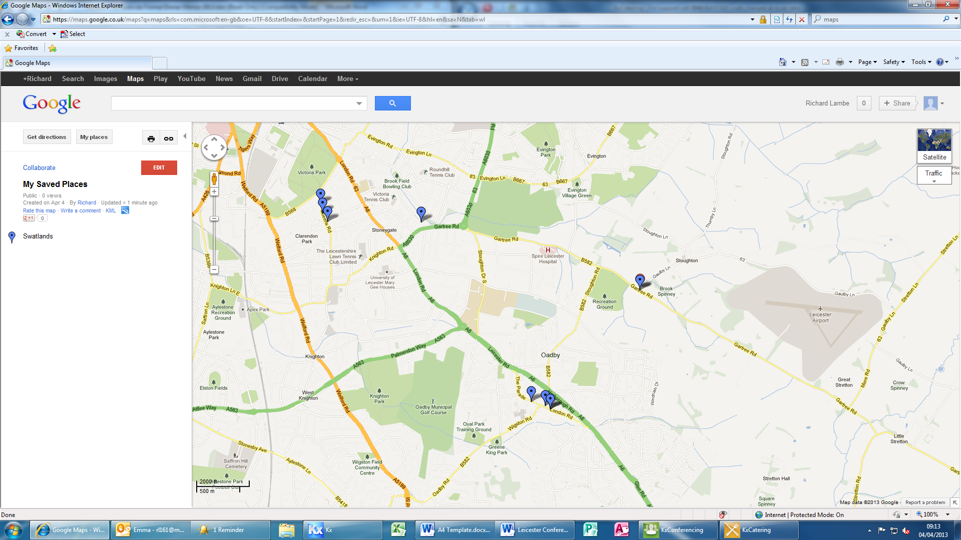
We are here!

