WSDL AND BPEL TO SRML-P LANGUAGE TRANSFORMATION

By

YI HONG

A Dissertation
Submitted to University of Leicester
in Partial Fulfillment of the Requirements
for the Degree of Master of Science
in Advanced Software Engineering
in the Department of Computer Science

Leicester, United Kingdom

September, 2006

DECLARATION

All sentences or passages quoted in this report from other people’s work have been specifically acknowledged by clear cross-referencing to author, work and page(s). I understand that failure to do these amounts to plagiarism and will be considered grounds for failure in this module.

Signed: __________________
Date: __________________

Table of content

1 Introduction 4
2 Project Aim and Objective 4
2.1 WSDL/BPEL to SRML-P Converter 5
2.2 Strategy Solutions 5
3 Background & Technologies 9
3.1 WSDL 9
3.2 BPEL 10
3.3 SRML-P in SENSORIA 11
3.3.1 SRML-P Module Diagram 11
3.3.2 SRML-P Specification 12
3.4 Programming Technologies 12
3.4.1 Programming language - Java 5.0 12
3.4.2 Document Object Model (DOM) 13
3.4.3 Graphical Editing Framework (GEF) - Draw2D 14
3.4.4 Standard Widget Toolkit (SWT) 15
3.5 Project Tools 15
3.5.1 Borland Together 15
3.5.2 Eclipse 16
4 Design Overview 16
4.1 Packages and Class Diagrams 16
4.1.1 Default package - Graphical User Interface 16
4.1.2 sensorial.convert.BPEL –Parser and Data Structure for BPEL & WSDL 17
4.1.3 sensorial.convert.BPELProcess –Java Data Structure for BPEL Process 19
4.1.4 sensorial.convert.SRMLP – SRML-P Code Generator 20
4.2 Component Integration 20
5 Parsing WSDL/BPEL with Java DOM 21
5.1 Store XML elements with Java Data structure 21
5.2 Parsing Algorithm 22
6 Graphical Representation of WSDL/BPEL document 24
6.1 Class Diagram View from WSDL document 24
6.2 Activity Diagram View from BPEL document 26
7 SRML-P Code Generation 30
7.1 Vocabulary WSDL/BPEL vs. SRML-P 30
7.2 Apply Transformation Rule 31
7.2.1 Draw SRML-P Module Diagram 31
7.2.2 Generate SRML-P Business Role 33
7.2.3 Generate SRML-P Business Protocol 37
7.2.4 Generate SRML-P Interaction Protocol & Wires 38
8 Testing 40
9 Further Research & Limitation 41
10 Conclusion 41
11 Appendix 42
11.1 WSDL/BPEL document for input -- myBankProcess.bpel 42
11.2 Sample SRML-P output from myBankProcess.bpel 45
11.3 SRML-P Interaction Types and Notations 45
11.4 SRML-P metamodel 46
11.5 Project Plan & Gantt chart 49
11.6 Install Guide 50
12 Bibliography 53

Introduction
This MSc individual project (CO7201) is a part of Sensoria Project, which is funded by European Community. University of Leicester is responsible for developing and implementing a high-level modelling language for Services-Oriented Architecture (SOA) -- Sensoria Reference Modelling Language (SRML-P) [1]. This language can be used in the development of Service Component Architecture (SCA).

In this project, a requirement is that some existing web services artefacts such as WSDL [2] and BPEL [3] needed to be import to this new framework so that people can analyse or re-design business process in SRML-P. I am supposed to work on this direction. In this case, the main task of my individual project is to design the transformation rules between WSDL/BPEL and SRML-P then implement a tool – WSDL/BPEL to SRML-P Converter which is aimed to transform WSDL/BPEL documents to SRML-P.

The software will be a Java application that should be able to parse an XML document comprised of WSDL and BPEL content, obtain web services descriptions and display them as class diagram and activity diagram. Finally, it can generate SRML-P module diagram and partial SRML-P code from WSDL and BPEL.

The solutions to the problem are to create a XML parser to read the input document, provide user the visualization of web services with Java graphical API, then apply transformation rules on predefined Java object to generate code. This document will describe the concepts and technologies used in the project as well as the design and implementation detail of the tool.

Project Aim and Objective
The main task of this project is to implement a Java application for language transformation which can convert a WSDL/BPEL document to SRML-P. WSDL and BPEL are XML-based languages for the formal specification of business processes and business interaction protocols; similarly, SRML-P is also a high level modelling language for describing services-oriented system, but of a different format and framework. This tool should provide easy-to-use interface that allow user to import selected WSDL/BPEL file from existing web services. Then the program should be able to parse these XML documents to retrieve the description of services. Besides, a graphical representation (inc. class diagram and activity diagram) of given WSDL/BPEL document will be displayed during the transformation procedures. Finally, the program will generate SRML-P diagram and a skeleton structure of SRML-P codes based on such information.

In order to process the transformation, we have to find out the corresponding concepts in SRML-P and WSDL/BPEL then formulize mapping rules for automatic conversion. It is one of the most important steps and essential precondition before implementing the transformation program using Java.

WSDL/BPEL to SRML-P Converter
WSDL/BPEL to SRML-P converter will take a WSDL/BPEL document as input, then generate SRML-P module diagram and specification codes (inc. Business Role, Business Protocol, Interaction Protocol and Wires) as output. The file on the left is the input document to the program while expected output document is shown on the right.

Sample Input (WSDL/BPEL file) Expected Output (SRML-P)

Transform

myBankProcess.xml

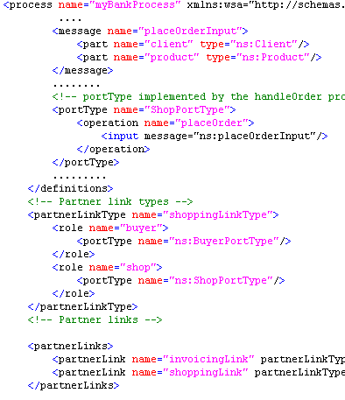
……..
SRML-P Module diagram and code
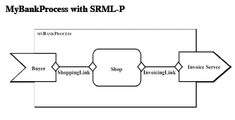
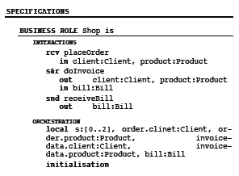

Figure 2.1 Sample input and expected output for WSDL/BPEL to SRML-P converter

Transformation procedure involves several main steps: Parsing XML document– Display Graphical Representation – Code generation. The detail will be described later.

Strategy Solutions
This section will briefly describe the possible solutions to the problem, including how many steps are required in the transformation, what should be done as well as how to achieve this in each step. The technical details will be discussed in section 4 to 7. WSDL/BPEL to SRML-P Converter will do the following thing in sequences:

Parsing WSDL/BPEL Document Using Java DOM
Both WSDL and BPEL are XML-based documents, the first thing to do is to import WSDL/BPEL and expose XML document as a tree structure comprised of nodes. To manipulate an XML document, BPEL files will be loaded into memory using an XML DOM parser (org.apache.xerces.parsers.DOMParser) which is provided by Apache Xerces. The strategy is to traverse WSDL/BPEL document in depth-first, width-second order. The parsing detail will be described in section 5.

Initialize Objects of WSDL/BPEL Classes
Although we can get all services information needed from WSDL/BPEL from the first steps, it is still not very convenient to convert DOM tree to SRML-P directly. Hence, two packages sensorial.convert.BPEL and sensorial.convert.BPELProcess were created to store those elements in predefined java data structures. It would be easier to apply transformation rule to these objects rather than DOM tree. After traversing WSDL section from BPEL document, WSDL/BPEL to SRML-P Converter will initialize several classes such as Message, PortType, PartnerLinkType, PartnerLink etc. in my package sensorial.convert.BPEL. Corresponding instance of WSDL/BPEL classes will be used in the following steps instead of WSDL/BPEL DOM tree.

Draw Diagram to Represent WSDL Interfaces and Roles
After parsing WSDL/BPEL document, the program will give user a graphical representation of how to access a web service and what operations it will perform. That is to draw a class diagram which contains all interfaces and operations provided or required in the web services based on the information retrieved from WSDL description. The diagram should also display the names of all roles and what interfaces each role should be able to provide. The Graphical Editing Framework (GEF) provides a painting and layout package called Draw2D [7], which can be used to draw this diagram dynamically. WSDL/BPEL to SRML-converter will be able to display a diagram below base on given information.
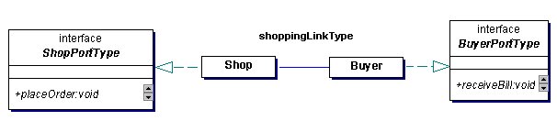

Figure 2.2 Represent Web Services from BPEL files using org.eclipse.draw2d

The sample WSDL/BPEL input is myBankProcess.bpel [Appendix 11.1]. In the diagram above, three interfaces ‘ShopPortType’, ‘BuyerPortType’ came from WSDL element ‘PortType’, which is a set of abstract operations. Shop and Buyer is the role in the services, they came from element ‘partnerLinkType’. The format of WSDL file will be described in the next section.

Display BPEL Activity Diagram
It is also very import to obtain web services workflow in BPEL. So WSDL/BPEL to SRML-converter will display an activity diagram base on the structure of the business process in BPEL. The activity diagram comes from BPEL process. Sequence (<sequence>) allows us definition of a set of activities that will be invoked in an ordered sequence. But there are some limitations, as time is not enough, I can only deal with some basic activities such as activities in sequences, binary decisions etc. some complex workflows such as loop and parallel process may not be preceded. Activity diagrams are typically used for business process modeling in BPEL. WSDL/BPEL to SRML-converter will draw the following activity diagram based on BPEL workflow.This part is implemented using Java Draw2D as well.

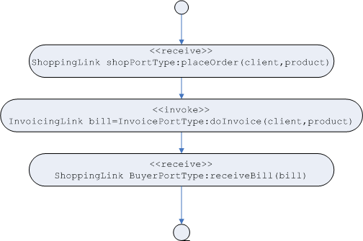
Figure 2.3 Activity Diagram base on BPEL process

This activity diagram consists of initial node, activities, flow (arrows) and final node. However, more complex diagram may contain branch such as condition and decision. Parallel activities are currently not supported by the tool. – In the diagram above, three activities are performed sequentially. Firstly, the shop received the method call ‘placeOrder’ with two parameters (client, product) from its client buyer. After that, the shop invoke operation ‘doInvoice’ of invoice services with the same parameters, which returns a value ‘bill’ to shop. Then, the shop call receiveBill(bill) on buyer. Finally the process ends. As we see, this activity diagram shows the detail of entire BPEL workflows
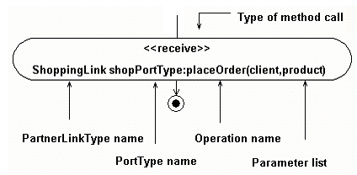
Figure 2.4 the meaning of each item in a single activity

This figure explains the meaning of each item in a single activity. Types of method call such as <<receive>>, <<invoke>> are described above, ‘shoppingLinkType’ is the ‘partnerLinkType’ of the activity. Each activity must specify ‘portType’ and ‘operation’ in its own attributes. The format of BPEL file will be discussed in section 3. Activity diagram is also implemented with Draw2d.

Apply transformation rule and generate SRML-P.
Finally, based on the information given in the previous steps, WSDL/BPEL to SRML-P Converter will be able to create SRML-P module diagram, SRML-P specification inc. Business Role, Business Protocol, Interaction Protocol and Wires.

The original idea was to make full use of a completed SRML-P metamodel and its eclipse plug-in editor based on EMF and GEF, which should be developed by another MSc student Amitabh Arun Lall., but as it has not been finished yet. In order to start implementation without a completed EMF model, I designed my own packages with SRML-P classes in Borland Together and did not use EMF/GMF framework. The project only uses package Draw2d in GEF but did not use GEF framework directly.

About SRML-P output format, SRML-P module diagram will be exported as JPEG file. SRML-P specification including Interactions and Orchestration in Business Role, Business Protocol and Interaction Protocol, all of them will have a textual representation. Due to the missing of a completed EMF model, they will only be store in plain text file rather than XML-based document.

Background & Technologies
This section will give a brief description of WSDL (Web Services Description Language) and BPEL (Business Process Executable Language) as the source language to be transformed, the input file of the tools is a combined document which contains both WSDL and BPEL content. In addition, output file of the program - SRML-P (Sensoria Reference Modeling Language), will be introduced in chapter 3. The basic structure and format of WSDL/BPEL/SRML-P document can be found in the appendix.

WSDL
Web Services Description Language (WSDL) is the standard format for describing a web service. A WSDL definition describes how to access a web service and what operations it will perform. WSDL is an XML format for describing network services as a set of endpoints operating on messages containing either document-oriented or procedure-oriented information. The operations and messages are described abstractly, and then bound to a concrete network protocol and message format to define an endpoint. It is a specification defining how to describe web services in XML grammar. WSDL describes four pieces of data: (1) Interface information describing all publicly available functions. (2) Data type information for all message requests and responses. (3) Binding information about the transport protocol to be used. (4) Address information for locating the specified service. [6]

WSDL/BPEL to SRML-P converter only need (1) and (2) part in a WSDL document. Because SRML-P document is higher level, it does not specify the data type in detail explicitly. Binding and address information is not needed during the transformation. When parsing WSDL, the program simply ignores these tags. To see a full WSDL document example, please refer to Appendix [11.1]. Obviously, WSDL document is a well-formed, validated XML document.

WSDL Core Elements
WSDL document defines the web services as elements in XML document. It is represented as collections of network parties or roles. The abstract definition of messages and roles is separated from concrete deployment, it is what SRML-P converter needed. A WSDL document uses the following XML elements in the definition of network services.

<types>: Element <types> declares the data type definition using XML Schema. Usually, it is a XSD file. This WSDL element will be ignored by the WSDL/BPLE to SRML-P converter. The reason is obvious, as a high level modelling language, SRML-P does not contain such information, thus it need not go inside to the concrete data type definition.

<message>: Element <message> is an abstract, typed definition of the data to be communicated. The <message> element describes a one-way message, whether it is a single message request or a single message response. It defines the name of the message and may contain zero or more message <part> sub elements. During the transformation, we will parse these elements to retrieve input/output parameters of each operation.

<Operation>: Element <operation> is an abstract description of an action supported by the service. In other words, it corresponds to a method in programming language. An operation may specify an input or output message, which can refer to message parameters or message return values. This element is also a key element to be parsed by SRML-P converter.

<PortType>: Element <portType> is an abstract set of operations supported by different roles. A portType may contain multiple operations. It can be represented as an interface in UML. The program will display this element as an interface in UML from WSDL view.

Although <Binding>, <Port> and <Service> elements are also core elements in WSDL document, they are not related to SRML-P content. In this case, the program will simply ignore these tags.

BPEL
Business Process Execution Language (BPEL) [5] is an XML-based language for the formal specification of business processes and business interaction protocols. BPEL extends the Web Services interaction model and enables it to support business transactions. It is the result of a cross-company initiative between IBM, BEA and Microsoft to develop a universally supported process-related language. To see a full BPEL document example, please refer to Appendix [11.1]. It starts from tags <partnerLinkType> in this example. A BEPL document is also a well-formed, validated XML document. More information about these can be found in the BPEL specification.

BPEL Core Elements
<partnerLinkType>: Element <partnerLinkType> characterizes the relationship between two services by defining the “role” played by each parties in the web services. It defines the name of the partnerLinkType and must contain one or two “role”, please notice that it is possible fore a partnerLinkType to contain exactly one role instead of two. Each role can only specify exactly one WSDL portType.

<partnerLink>: Element <partnerLink> is characterized by a partnerLinkType which is defined above. The role is specified by its attribute myRole while the role of the partner is specified by another attribute partnerRole.

When the partnerLinkType of partnerLink only has one role, the other attribute can be omitted.

<variable>: Element <variable> offer the possibility to store messages that hold the state of the process. The messages that get stored are most of the time either coming from partners or going to partners. Variables also offer the possibility to store data that is only state based and never send to partners.

<sequences>: tags can involve several kinds of activities. A collection of activities inside <sequences> will be performed sequentially. But the converter will only deal with following elements. (1)<invoke> business process can invoke a one-way or request-response operation on a specific portType provided by a partner. (2)<receive> The process will do a blocking wait until it receives the message it required. (3)<reply> the combination of a <receive> and a <reply> forms a request-response operation on the WSDL portType for the process. (4)<assign> this element allow user to copy data from one variable to another. (5)<switch> <case> allow process to select one branch depended on some conditions.

Note: <flow><while><pick><wait> etc. these tags are currently not supported in SRML-P converter. They will be supported in the next version, if possible.

SRML-P in SENSORIA
Sensoria Reference Modelling Language (SRML-P) is a high level modelling language that is able to model individual business components and interconnect them to build complex applications in a service-oriented way. A small example of SRML-P can be found in the appendix. This section will give a brief description of the target language, the output file of the tool. SRML-P is completely different from WSDL and BPEL these two services description languages. First of all, it is not a well-formed XML file as WSDL and BPEL we described above. Secondly, it contains diagram and its own notations which never been used in WSDL nor BPEL. You will see the basic structure and the definition of a SRML-P document in the following section. More information can be found in SRML-P specification [1].

To see a full SRML-P document example, please refer to Appendix [3]. It consists of module and specification (inc. business role, business protocol and interaction protocol)

SRML-P Module Diagram
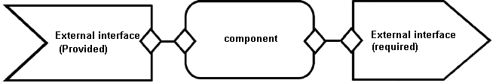
Figure 3.1 SRML-P module diagrams

Figure 5 is the notation of a SRML-P module. It is the core of SRML-P. They present the component as well as external interfaces for required and provided services. Components and external interface are nodes of the graph while internal wires connect them. Components are instances of Business Role, External interfaces (both provided and required) are instances of business protocol.

SRML-P Specification
SRML-P module: a SRML-P module consists of a number of components, external interfaces (provides or requires) and wires that connected each other.

Business roles: a business role is the centre component of the services. It is specified by declaring a set of interactions and the way they are orchestrated. In the diagram above, a component is an instance of business role. Business role consists of Interaction and Orchestration. Interaction combines multiple operations it provided and requested. Orchestration consists of several transitions. These transitions will be trigged by some events while the precondition is true, that means it is an event-based system.

Business protocol: external interface are specified through Business protocol. Business protocol contains Interaction and Behaviour. In the diagram above, all external interfaces are of type business protocol.

Interaction protocol: Interaction protocol establishes a relationship between two parties. The interactions in which they are involved are called role A and role B.

Programming Technologies
This section will describe the programming language and the technologies used in WSDL/BPEL to SRML-P converter. This tool should be able to run on any platforms, we choose object-oriented Java as programming language. As a result, all technologies used in this project are related to Java.

Programming language - Java 5.0
Java 2 Platform Standard Edition is a major feature release. JDK 1.5 introduces several extensions to the Java programming language. This is one of the reasons why I choose it for developing this project. Some new features such as Java Generics (JG) are widely used in the implementation of WSDL/BPEL to SRML-P Converter. Here is an example taken from my code (PortType.java) which use new feature of Java Generics.

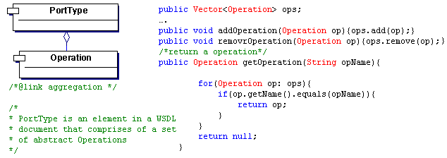
Figure 3.2 Java code segment -- implement BPEL/SRML-converter using JDK 1.5

We can see that declaration above reads as “Vector of Operation ops.” The code using generics is clearer and safer.

Java also gets linguistic support for enumerated types. I am using enumerated types for WSDL/BPEL tags. Although enumerated types can be define in old style as follow
Example 3.1
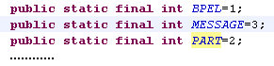
The code above is an old way to represent an enumerated type in prior Java releases. But this pattern has many problems, such as typesafe problem and no namespace. With the new feature of Java 5.0, enumerated types can be used to define all XML tags in WSDL/BPEL files
Example 3.2
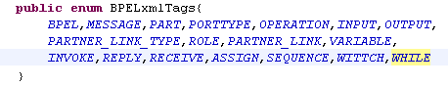
The code segment above as an example taken from the system (BPELxmlTags.java) which uses the new feature of enumerated types. It is much better and easier to check and understand than the previous one. It is the standard way to represent an enumerated type in Java 5.0.

As many new features of JDK 1.5 are widely used in programming, this program must be compiler with JDK 1.5 and run with its corresponding runtime library. The Java source file will not be compiler with a lower version of JDK. If you attempt to run the program with JRE 1.4, it will not work properly but throw an exception.

Document Object Model (DOM)
Document Object Model (DOM) is a form of representation of structured documents as an object-oriented model. Both WSDL and BPEL document are XML-based document and we have to load them as the input source, in this case, the program need to parse them as a tree structure comprised of nodes. As WSDL/BPEL file are both small documents, DOM Parser is more efficiently. That is the reason why I choose DOM parser rather than SAX.

Xerces dom parser ‘org.apache.xerces.parsers.DOMParser’ provided by Apache is used to parse WSDL/BPEL documents. The basic algorithm is to traverse WSDL/BPEL document in depth-first, width-second order.

Procedure visitTree (node : WSDLTreeNode)
If node is empty Then exit
If node is a portType element Then
Add the name of this node to a Vector
End if
If node has children Then
For each child of node
Do visitTree (child)
End if
End procedure

The Pseudo-code above will describe the algorithm about how I retrieve the all names of portType elements in WSDL file. After traversing entire DOM tree, the program will be able to access all nodes including their attributes and values. But if the WSDL/BPEL document is not a well-formed XML document, the parser will not be able to work. In case of some XML tags are missing, it may result parsing problems even the document is well-formed. For example when visit a WSDL node <input message=”receiveBillInput”>, here it specified the parameters list with attribute ‘message’, if node <message name=”receiveBillInput”> does not exist, the program will throw an exception. Therefore, it is necessary to check the well-formedness, validity and element dependence of the input file before doing the transformation.

Graphical Editing Framework (GEF) - Draw2D
Although WSDL/BPEL converter does not use Graphical Editing Framework (GEF) directly, it actually uses a painting package called Draw2D (org.eclipse.draw2d), which is provided by GEF. Draw2D provides lightweight rendering and layout capabilities on an SWT Canvas. Draw2d is for drawing. GEF (Graphical Editing Framework) is for editing, however, Draw2D is able to manipulate the data, accessibility support such as native drag and drop is also possible in Draw2D. This tool only needs to provide a graphical representation without making the diagram editable.

Moreover, it is impossible to develop a standalone GEF application without use of the Eclipse platform so far. In this case, there is another reason for using Draw2D rather than GEF. Therefore, Draw2D may well be a good choice for doing this in Java. In this system, all diagrams including class diagram, activity diagram and SRML-P module diagram are created by Draw2D.

Standard Widget Toolkit (SWT)
The SWT (or Standard Widget Toolkit) is a framework for developing graphical user interfaces in Java [9]. SWT component emerged recently and it is designed to provide efficient access to the user-interface facilities of the operating systems on which it is implemented. It is another choice besides AWT & Swing provided by Sun as standard package java.awt & java.swing. Both AWT& Swing and SWT are easy to use for developing standalone application. Personally, I am familiar with AWT & Swing framework as I had some experiences with Swing-based desktop application. But in this project, Draw2D package will be used for implementing graphical representation. All instances of Draw2D class of type IFigure must be drawn on a SWT canvas. In other words, the program has to be a SWT-based application. As a result, SWT is a better solution for user interface design.

Once this issue is settled, we have to choose an IDE such as Eclipse (this will be discussed in next section) to create a user interfaces. Two packages: org.eclipse.swt and org.eclipse.swt.widgets are required by SWT application. All Java UI classes should import these two packages in order to create GUI component and handle events.

Project Tools
This section will describe the Modeling Tools and Integrated Development Environment (IDE) that used within the project. With the help of these tools, it will be easier to create project more quickly and efficiently and increase the reliability as well as performance.

Borland Together
Borland Together [10] is an UML modeling tool for designing software architecture. It is a visual modeling platform designed for programmer and designer that can help them greatly increase the productivity and quality by automating design and code reviews. Borland Together is mainly used in the early phases of the project.

The UML is a very important part of developing object-oriented software and the software development process. Firstly, the UML class diagram of WSDL/BPEL to SRML-P converter was designed in Borland Together. All classes together with attributes, operations and their associations, inheritance relationships and composition associations were specified in Borland Together. This will generate the skeleton of the system and some Java source files. However, all methods in the classes are empty.

Generated classes are still needed to be completed, e.g.: Sometimes Borland Together do not generate Java source code very well, especially aggregation or composition relationship between classes. For example, we have to type Vector<className> classSet manually to implement composition relationship in Java.

Eclipse
Eclipse [11] is an open source platform-independent software framework that provides perfect development tools for developing Java project. The toolkit include a Java perspective, a Java debug perspective, a Java editors, views, wizards, refactoring tools and Java compiler. As we have chosen SWT (org.eclipse.swt) and Draw2D (org.eclipse.draw2d) in the beginning of the project, both of them are closely related to Eclipse platform, so it is not doubt that Eclipse will be used as develop tool in this project.

In the previous step, a basic framework of the system was generated by Borland Together automatically. Then the Java source code will be imported to Eclipse for editing and debugging. With the help of Eclipse, we can make full use of JUnit, which is a simple framework to write repeatable tests. It can be used for testing reliability of each class, this part will be discuss in section 8.

Design Overview
This section will show the design and framework of WSDL/BPEL to SRML-P converter. It will give a brief description of all packages in the system as well as the responsibility of each package. In addition to package description, core class diagram will be given for each package.

Packages and Class Diagrams
WSDL/BPEL to SRML-P converter contains four main packages as follow

1 Default package for Graphical User Interface
2 Package sensorial.convert.BPEL
3 Package sensorial.convert.BPELProces
4 Package sensorial.convert.SRMLP.

Default package - Graphical User Interface
All SWT GUI classes such as main window and other input dialog windows are placed in default package. Main.java is the launcher of the whole project. It is also the main window of the system that can display several CTableFolder and CTableItem SWT components for user to switch form different views.
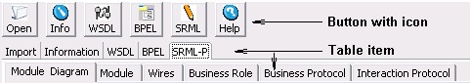
Figure 4.1 Buttons with icons and Table Items in WSDL/BPEL to SRML-P converter

At the beginning, only one item such as ‘import’ was displayed so that users can select a WSDL/BPEL file from local system by clicking the button, the other items are not visible. After selecting a XML file, the rest items including Information,WSDL view, BPEL view and SRML-P view will be shown as well. Some of them may contain sub tab items. For example, there are several sub tabs within SRML-P main tab. When SRM-P view is visible, all its sub tabs including Module Diagram, Module, Wires, Business Role, Business Protocol and Interaction Protocol will automatically become visible. However, menu can be used to switch from one view to another.
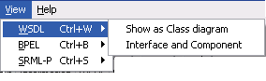
Figure 4.2 ‘View’ menu in the main window
An alternative way for opening a view is to use menus. View menu includes options that control the. The commands on this menu affect the switch of different views. Besides, WSDL/BPEL/SRML-P documents also display their graphical representation on SWT canvas of this main window. I will discuss the detail of this part in section 7. This package is quite simple without inheritance or other complex associations and just designed for UI for interactions. I will not provide a class diagram of this package.

sensorial.convert.BPEL –Parser and Data Structure for BPEL & WSDL
Package sensorial.convert.BPEL was designed for parsing WSDL/BPEL documents. The main class BPEL.java uses org.apache.xerces.parsers.DOMParser as parser. All WSDL and some BPEL tags such as <partnerLinkType> and <variables> will be parsed by the program in this package. But BPEL processes inside tag <sequences> are not processed in this package. They will be processed in a separated package sensorial.convert.BPELProcess which will be discussed in the next chapter.
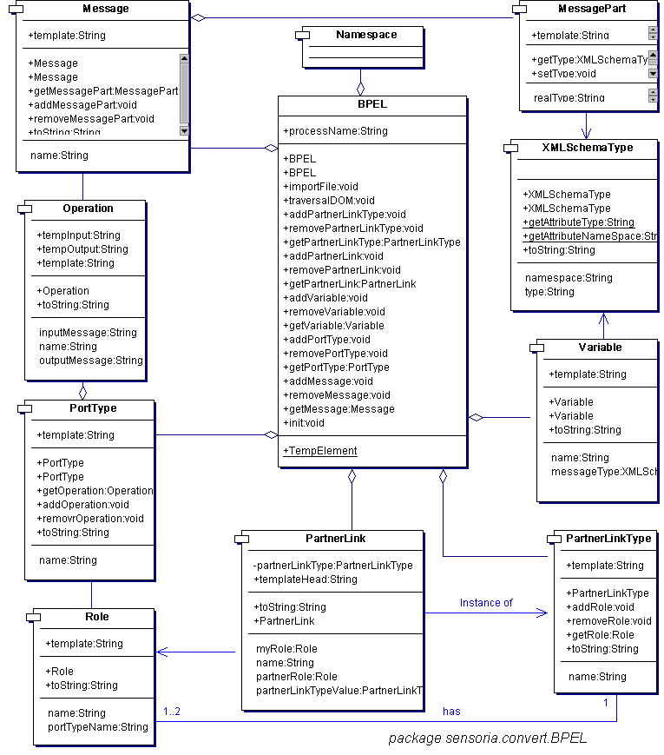
Figure 4.3 class diagram of package sensorial.convert.BPEL

Note: As the diagram is too large to be put inside the documents some of the attributes are hidden.

Form the class diagram above, it is noticeable that class BPEL is the main class of the package. An instance of class BPEL may contain WSDL elements such as portType, message etc. PortType is an element in a WSDL document that comprises of a set of abstract operations that each refers to input and output messages that are supported by the service. Aggregation represents the correlation between PortType and Operation. In BPEL a Web Service that is involved in the process is always modeled as a partnerLink. Every partnerLink is characterized by a partnerLinkType which is defined in the WSDL definition, that is to say a partnerLink element is an instance of partnerLinkType element. A partnerLinkType specifies the role and the type of a partner. Every partnerLink has to have a unique name that can be used to identify the partnerLink. The role of the process is specified by the attribute myRole and the role of the partner is specified by the attribute partnerRole. When a partnerLinkType is used with only one role, then one of these attributes can be discarded.

sensorial.convert.BPELProcess –Java Data Structure for BPEL Process
This package defines and implements several activities in the business process of BPEL document. Seen form the class diagram below, it is noticeable that almost all classes in this package are drawable classes that inherit abstract classes in package Draw2D. Those classes not only represent the business process of a BPEL file but can also be used as figures displayed in the activity diagram.

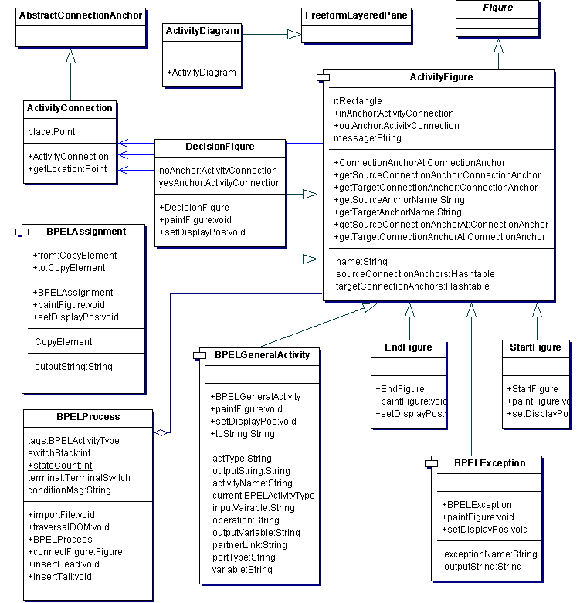 Figure 4.4 class diagram of package sensorial.convert.BPELProcess.
Note: only core classes in the package are listed above.
The superclass of all BPEL activities is ActivityFigure, which inherits standard class Figure from package Draw2D and made it drawable. In the diagram below, we can find the connectional relationship between these classes and UML activity diagram.

Class StartFigure corresponds to initial activity in UML which shows the start point of the first activity. The figure was denoted by a solid circle. Similarly, the corresponding concept of class EndFigure is the final activity in activity diagram. Class BPELGeneralActivity simulates three types of elements -- <invoke>, <reply> and <receive> method call in a business process. Likely, BPELAssignment presents the <assign> elements that copy the data from one variable to the other.

sensorial.convert.SRMLP – SRML-P Code Generator
This package is designed for generating SRML-P specification and Module Diagram. However, his package does not provide a complete Java data structure for SRML-P, it is just a code e generator .So far, we do not have a completed metamodel for SRML-P. In this case, I created these packages without EMF. But this package offers the ability to export an SRML-P Module Diagram as JPEG file and save Business Role, Business Protocol and Interaction as plain text.

Component Integration
The following component diagram shows WSDL/BPEL to SRML-P converter modules and their dependencies.
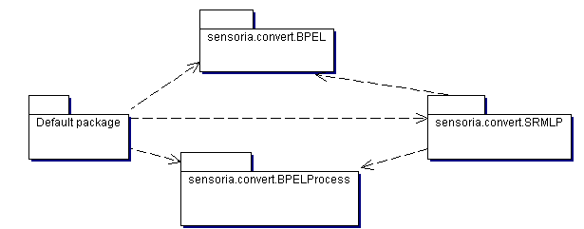
Figure 4.5 Package Dependencies of the system
Form the diagram above, the package relationships are defined as follow: Default package needs the other three packages and package sensorial.convert.SRMLP needs BPEL and BPELProcess to generate SRML-P interaction and SRML-P orchestration respectively.

Parsing WSDL/BPEL with Java DOM
As mentioned in chapter 2.2.1, WSDL/BPEL to SRML-P converter uses Apache Xerces, which is a fully conforming XML Schema processor, to parse XML document. In order to use those API, Three jar files xml-apis.jar,xercesImpl.jar and resolver.jar need to be added to the default environment variable CLASSPATH. This section will describe the basic parsing algorithm and the Java data structure used for storing XML elements.

Store XML elements with Java Data structure
All web services description in WSDL/BPEL documents is XML-based, but we have to manipulate the data in java. That is to say, XML-based data have to be transformed to java data structure as alternative representation. In this case, a high level of abstraction should be defined at the beginning.

For example, in the WSDL document below, an element <operation> may contain an input message and output message. That WSDL description shows operation ‘doInvoice’ contain both input messages and output message, input message specified the input parameters of the operation while output message specified the return value of the method.

<operation name="doInvoice">
<input message="ns:doInvoiceInput"/>
<output message="ns:doInvoiceOutput"/>
</operation>

The WSDL description below specified the detail of input message and output message of the method ‘doInvoice’

<message name="doInvoiceInput">
<part name="client" type="ns:Client"/>
<part name="product" type="ns:Product"/>
</message>
<message name="doInvoiceOutput">
<part name="bill" type="ns:Bill"/>
</message>

From the WSDL above, we can write the method in Java by hand as follow:

public Bill doInvoice(Client clinet, Product product)

It looks quite easy, but actually the operation name, input parameters list, output variable are specified in different DOM tree nodes. Three separated classes are created to store the XML code segment given above.

class Operation{
Message inputMessage;
Message outputMessage;
}

class Message{
Vector<Parameter> parameterList;
}

class Parameter{
emun dataType;
String parameterName;
}

Now, it is possible to represent XML-based information in java data structure designed above.

Parsing Algorithm
The basic algorithm was described in chapter 3.4.2. That is to traverse the DOM tree in a depth-first, width-second order. Usually it was implemented by revoking a recursive function. The algorithm is very similar to traverse a binary tree (Although a DOM Tree node may contain more than two children). But it is still not easy to retrieve all nodes required to initial an instance of the Java data structure we defined in the last chapter.

The following Pseudo-code describes how to invoke a recursive function getAllWSDLOperation to traverse entire WSDL document and for each <operation> element, create an instance of Operation and add this instance to a Vector operationList. The key point of this algorithm is to identify the start tags and close tags of each element in XML document. So we have to check the tag name of current node before and after recursive function call.

The algorithm of reading other WSDL/BPEL elements and initialing their corresponding instances are very similar to the one I show below. Suppose we have Java data structure Operation & Message that defined in the last chapter. The algorithm also declares some temporary static global variables. The Pseudo-code is shown below.

operationList:Vector
op:Operation
msg:Message

//Pseudo-code of getAllWSDLOperation

Procedure getAllWSDLOperation (node : WSDLTreeNode)

If node is empty Then exit
//The exit of the recursive function
If node is a Operation element Then
//check start tags <operation>
op:=create a new Operation with node.name
End if

If node is a Message element and op is not empty Then
//check start tags <message>

If node is type of input Message Then
op.input:=create a new Message with node.name;
End if
If node is type of output Message Then
op.output:=create a new Message with node.name;
End if

If node has children Then
For each child of the node
Do getAllWSDLOperation (child)//recursive call
End loop
End if
End if

If node is a Message element and op is not empty Then
//check end close tag </operation>
add op to Vector operationList //add the operation to the method
set op:=null
End if
End procedure

Once this function is executed, it will traverse entire XML DOM tree and append the specified instance of Operation to the end of Vector operationList.

Graphical Representation of WSDL/BPEL document
In the last chapter, WSDL/BPEL document was imported and represented in Java data structure. Now what we have to do is to show such information in a graphical way. Similarly, another jar file eclipse.draw2d_3.1.1.jar must be added to the CLASSPATH variable. SWT class Tree and Package Draw2D will be used here. As long as the WSDL/BPEL to SRML-P converter traverses the whole XML document, it will display all elements as a tree as follow.

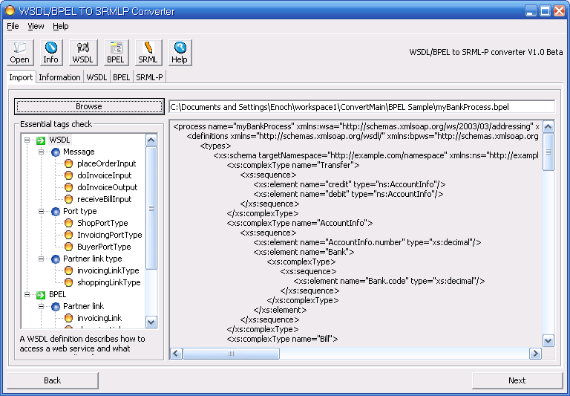
Figure 6.1 display WSDL/BPEL elements in a tree view structure

The picture above shows how WSDL/BPEL to SRML-P convert displays selected WSDL/BPEL document.

Class Diagram View from WSDL document
As long as the program parses the document, the next step is to give a graphical representation of WSDL document. The best way is to draw a class diagram which contains all interfaces and operations provided or required by the service endpoints. WSDL/BPEL to SRML-P converter uses package Draw2D to draw a class diagram dynamically from the WSDL description. The example below shows how WSDL/BPEL to SRML-P converter generates the class diagram on the screen form WSDL.

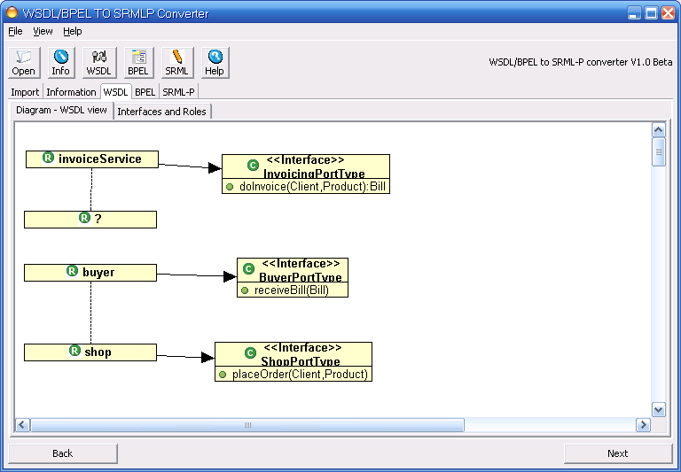
Figure 6.2 Class Diagram represented Roles and Interfaces of a WSDL document

All figures can be moved to any places on the canvas because a class which implemented MouseListener was added as observer. This observer handles mouse events that occur on canvas so that users are able to drag and drop any figures to rearrange the layout.

In some cases, it is possible to define a PartnerLink with only one role element. In the program, this role will displayed as a question mark -- which implied this service expresses willingness to link with any other services. The picture below illustrates the definition in detail.
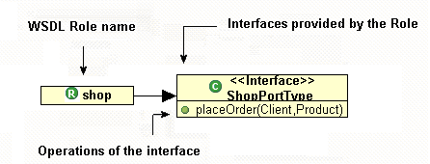
Figure 6.3 Explanation of each item in the diagram

The sample input of this diagram is myBankProcess.bpel [Appendix 6.2]. In the diagram above, three interfaces ShopPortType, BuyerPortType came from WSDL element PortType, which is a set of abstract operations. Here is a WSDL example where the diagram above comes from.

Example 3
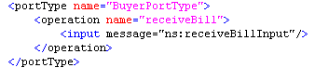
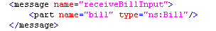
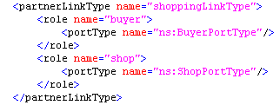

Each operation refers to an input message and output messages. Message element represents an abstract definition of the data being transmitted. A message consists of logical parts, each of which is associated with a definition within some type system. We combine these fragments (PortType, Message, and Operation) to generate proper interface description. Three Roles InvoiceService, Shop and Buyer came from BPEL element PartnerLinkType. A partnerLinkType characterizes the relationship between two parties by defining the roles played by each of the party in the conversation and specifying the portType provided by each party to receive messages. Each role specifies exactly one WSDL portType element. [6].

This class WSDL view gives user a better understanding on the responsibility of each role the interfaces it provides or requires. So it is very important to have this information before transforming the whole document to SRML-P. This diagram is also the source where SRML-P interactions come from during the period of code generation.

Activity Diagram View from BPEL document
So far, we have got the graphical representation of WSDL content, which will be transformed to SRML-P interactions. Another important part is the business process. This tool will display business process as activity diagram. The picture shows the activity diagram generated by WSDL/BPEL to SRML-P converter.

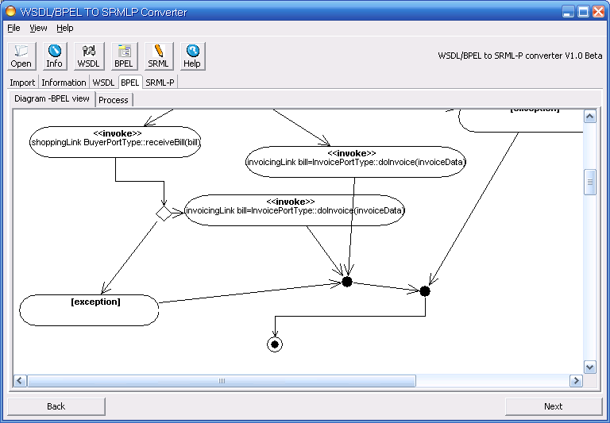
Figure 6.4 Activity Diagram represented the Business Process in the program

The follow diagram illustrates a general BPEL activity. All information of this activity comes from BPEL <partnerLink> element. All the items are specified as attributes of element <partnerLink>.

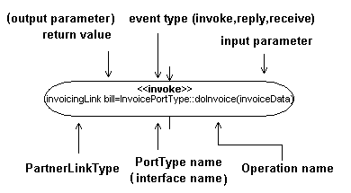
Figure 16 a general BPEL activity

Example 4 – BPEL basic activity example

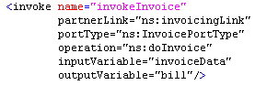

The program still uses Draw2D to draw these figures. For each basic activity, I create a single class that inherited class org.eclipse.draw2d.Figure. Each activity class overrides its corresponding paintFigure method in order to draw a different sharp.

Example 5 – Override paintFigure() method to Display a final activity “”

public void paintFigure(Graphics g) {
Rectangle r = bounds;
...
g.drawOval(r.x + r.width / 2-(r.height)/2,r.y,r.height-1,r.height-1);
//draw the outer circle
g.setBackgroundColor(ColorConstants.black);
g.fillOval(x+w/4,y+h/4,w/2,h/2); //draw the inner circle and fill it
}

Take final activity (end node) as an example, it is used to indicate terminal activities of business process and displayed as.Class EndFigure of this notation contains an attribute ActivityConnection inAnchor .which indicates a potentials connection with other activities.

There may be some complicate examples that combine basic activities with structured activities [13]. Structured activities offer a way to structure a BPEL process. The structured activities of BPEL describe the flow of a process by structuring basic activities, including basic sequence control between activities offered by tag <sequence> <switch> and <while>. So far the program is able to deal with <sequence> and <switch> tags. When it detected a switch-case statement, it will draw a decision figure which is depicted by a diamond, with the operations written on every side of the arrows emerging from the diamond. The condition of each ‘case’ will be displayed on the line by setting the value of ‘ToolTip’.

The most different part in drawing an activity diagram is not only to add activities but also connect them to construct the event workflow. In the program, any activities can be connected via PathFigure, which extends PolylineConnection. The program should support nested switch-case statement as follow

Example 6 – Nested switch case statement

<switch name=’Outer_switch_case_statement’>
<case condition=”boolean Expression1”>
<switch name=’Inner_switch_case_statement’>
<case condition=’ boolean Expression2’>
<receive name=../>
</case>
<case condition=’ boolean Expression3’>
<invoke name=../>
</case>
</case>
<case condition=” boolean Expression4”>
<reply name=../>
</case>
</switch>

The BPEL process above is a nested switch-case statement which can be represented as activity diagram shown below. Each line between two figures is numbered from 1 to 8.
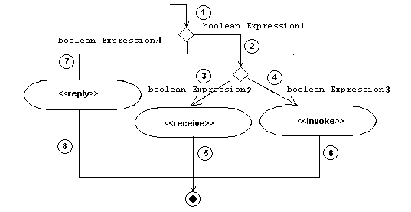
Figure 6.5 Show nested switch-case statement with activity diagram

There are many different strategies and abstract data types for storing a graph, either adjacency list or adjacency matrix. Both of them just store nodes without actual lines of the diagram .Instead of adjacency list or matrix, I use an ArrayList to store all figures in the diagram including their connections.
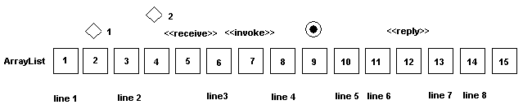
Figure 6.1.5 Store activity diagram using java.util.ArrayList

The basic algorithm is not complex, but we have to use a stack to store the current level of switch-case statement, firstly the program got a BPEL <switch> element, a decision figure was added to the Arraylist, we simply set current stack=1. After that, we add another nested <switch> element, stack=2. Besides, an instance of FigurePath which connects the previous two nodes is created and added to the ArrayList. Similay, BPEL element <receive> and <invoke> are detected and added to the ArrayList together with line 3 and line 4. Keep on doing this until </switch> tag is detected. By counting a stack level, <case> node will be linked to its corresponding <switch> node. But there are still some limitations, a few activities such as parallel

As long as we generate those UML figures and store them in the ArrayList, it is easy to display them using a loop in the following Pseudo-code.

Procedure drawBPELfigure(activities: ArrayList)
For each figure in activities
If figure is a Line Then drawLine(figure)
If figure is a BPELGeneralActivity Then drawFigure(figure)
. . . . .
End loop
End Procedure

It could be seen from the code above, the program will draw each BPEL figure according to its type, whether it is a Line or a basic activity or structured activity.

SRML-P Code Generation
The aim of the program is to generate partial SRML-P diagram and code. Based on the information given in the previous steps, WSDL/BPEL to SRML-P Converter will be able generate SRML-P module as well as three different types of entities – components, external interfaces and wires, which are instances of Business role, Business protocol, Interaction protocol.

The following chapter will give a vocabulary of both WSDL/BPEL and SRML-P, so that we can find the corresponding concept of each other.

Vocabulary WSDL/BPEL vs. SRML-P
Services description in section <message>,<portType>,<partnerLinkType>, <partnerLink> will be transformed to section Interactions of Business Role or Business Protocol in SRML-P without looking inside business process.

WSDL/BPEL tags or comcept SRML-P concepts

<portType> → SRML-P Interface of ‘Business Role’ or ‘Business Protocol’
<operation> → SRML-P operation in Interaction
<message> → parameter list in SRML-P operation.
<PartnerLinkType>→ association between ‘Business Roles’, ‘Business Protocols’
<PartnerLink> → Instance of association between ‘Business Roles’, ‘Business Protocols’
<variable> → ’ local’ section of ‘Business Role’

<sequences><switch><case><while> etc.
→‘Orchestration’ section of ‘Business Role’, but SRML-P is even- based.
So it does not use such structured activities to control the workflow.
<onMessage> →’ Transition’ section of ‘Business Role’
<wait> →setting alterDat interval e to wait for something
<flow> →BPEL parallel activities,

These concept mapping is an essential step before SRML-P code generation. But not all tags has corresponding concept in SRML-P.

Apply Transformation Rule
This section will discuss the transformation rule from WSDL/BPEL to SRML-P. The following chapters show how SRML-P module diagram and SRML-P business role, business protocol and interaction protocol are generated.

Draw SRML-P Module Diagram
Module diagram is the core of SRML-P. They present the components and external interfaces for required and provided services. Components are instances of Business Role, External interfaces are instances of business protocol (Both required & provided).

We can obtain all roles in the services from BPEL <partnerLinkType> elements. In case of the myBankProcess.bpel Appendix [11.1], there are three roles in the services, shop, buyer and invoiceServices. All of them will be appended to a List component in the main window..

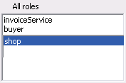
Figure 7.1 all roles in the services were listed in the box

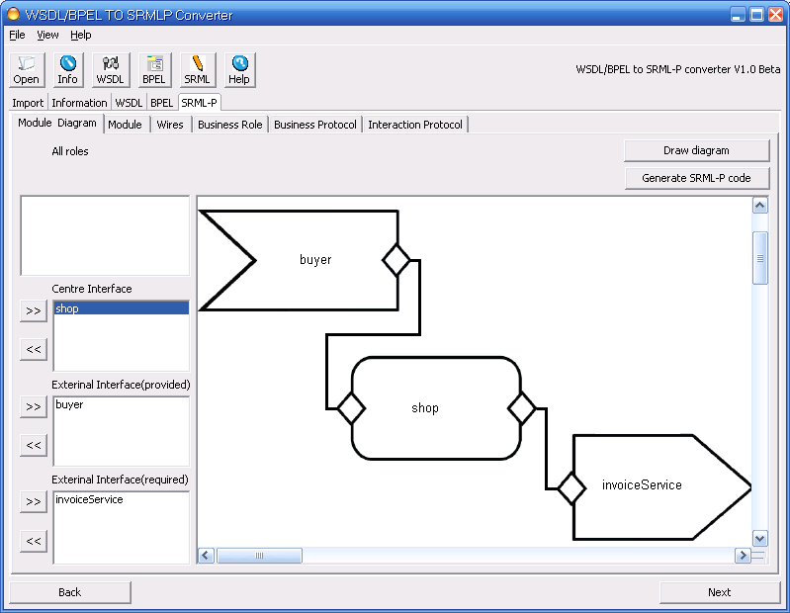

Figure 7.2the implementation of SRML-P module diagram

This user interface above can be found in ‘Module Diagram’ within main tab ‘SRML-P’.

A <partnerLinkType> element in BPEL specifies the role and the type of a partner. Every partnerLink has to have a unique name that can be used to identify the partnerLink. The role of the process is specified by the attribute myRole and the role of the partner is specified by the attribute partnerRole.

It is easy to identify which roles are centre elements easily according to attribute ‘myRole’, external interfaces are defined as partnerRole, but user still have to choose partnerRole as external interface (provides) or external interface (require). In the example: ‘myBankProcess.bpel’ [appendix 11.1]. Shop is classified as centre component of the services according to ‘myRole’ attribute. User is able to select an item from ‘All roles’ box on the top then click button to add the item either as External interface (provided) or External interface (required).

After that, by clicking ‘draw diagram’ button, the tool will generate SRML-P module diagram on the window. This program is able to export the diagram in JPEG format.

Generate SRML-P Business Role
A SRML-P centre component in module diagram is an instance of business role. As an example, consider the business role fulfilled by a shop. It shows the basic structure and format of a typical SRML-P business.

BUSINESS ROLE Shop is
INTERACTIONS
rcv placeOrder
in client:Client,product:Product
s&r doInvoice
out client:Client,product:Product
in bill:Bill
snd receiveBill
out bill:Bill
ORCHESTRATION
local
s:[0..2]
order.client:Client,order.product:Product
invoiceData.client:Client,invoiceData.product:Product
initialisation
s=0
termination
s=2
Transition receiveOrder
triggerBy placeOrder[init-event] ?
guardedBy s=0
effects
invoiceData.product:=order.product
^invoiceData.client:=order.client ^s=1
sends
doInvoice[init-event]!
^doInvoice.client=invoiceData.client
^doInvoice.product=invoiceData.product
Transition invokeInvoice
triggerBy doInvoice[init-event] ?
guardedBy s=1
effects
bill=doInvoice
^s=1
sends
receiveBill[init-event]!
^ receiveBill.bill=bill.bill

This SRML-P business role was transformed from myBankProcess.bpel Appendix [11.1] .A business role consists of two main parts: INTERACTIONS and ORCHESTRATION.

Firstly we have to deal with INTERACTIONS, which contain several operations in the following structure.

Example 7 – SRML-P Business Role Source Code

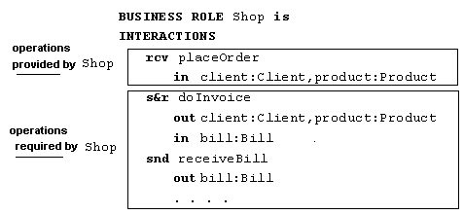

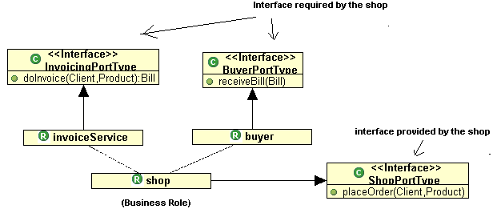
Figure 7.3 Example: Operations in a SRML-P interaction

Notice that the co-parties (invoiceService, buyer) of the shop in these interactions are not named. If an operation exists in the interaction of a business role, there are two possibilities: (1) the method belongs to the role itself (2) the method belongs to another class but required by the role.

In the code above, s&r is the type of interaction predefined by SRML-P. It means this interaction (doInvoice) is initiated by the party and expects a reply from its co-party. While waiting for the reply, the party does not block. There are 8 types of interaction including r&s, s&r, rcv, snd, ask, rpl, tll and prf, the definition of each type in SRML-P please refer to Appendix [8.2]. The rest part of SRML-P interaction can be defined in Java as “public Bill doInvoice(Client client, Bill bill)”. It is noticeable that all those information except interaction “s&r” comes from WSDL description we discussed in chapter 6.1.

The only problem is how to get the type of interaction such as r&s etc which is not directly provided by WSDL description. Usually, only four types of interaction will be taken into consideration during the transformation.

First of all, search for portType element by the role we found, then for each operation, user the follow procedure to check its SRML-P event type.

(1) One-way Message --The service receives a message. The operation only has a single <input> element. In case of one-way message, SRML-P event type is rcv if this operation belongs to myRole, otherwise (operation belongs to partnerRole and required by this role) it is indicated as snd.

(2) Request-response --The service receives a message and sends a response. The operation therefore has one input element and an output element. To encapsulate errors, an optional fault element can also be specified. In case of Request-response, SRML-P event type is r&s if this operation belongs to myRole, otherwise (operation belongs to partnerRole and required by this role) it is indicated as s&r.

(3) Notification --The service sends a message. The operation therefore has a single output element. In case of notification message, it is indicated as r&s or s&r. SRML-P interaction does not have input parameters is the only difference compared with the previous one

ORCHESTRATION [2] is another important section in SRML-P Business Rule. SRML-P orchestration contains a set of variables that provide an abstract view of the state of the component, and a set of transitions that model the activities performed by the component, including the way it interacts with its co-parties

The first part in SRML-P ORCHESTRATION is ‘local’, it declares some the variables in the services (e.g.: client, order, invoiceData, product in this example), this can be transformed from BPEL <variable> elements directly. Here s is used to model control flow, including the way the component reacts to triggers in the transition. s:[0..2] means there are three different states in the process. SRML-P Transition may modify the value of s to enter a new state. Initialisation specified the initial value of s while termination specified the terminal state, for example, if s=2, then the process ends.
local
s:[0..2]
order.client:Client,order.product:Product
invoiceData.client:Client,invoiceData.product:Product
initialisation
s=0
termination
s=2
Transition is the most significant part in SRML-P ORCHESTRATION. It consists of server parts: triggerBy guardedBy, effects and sends. Here is an example which shows the structure of a transition.

Transition receiveOrder
triggerBy placeOrder[init-event] ?
guardedBy s=0
effects
invoiceData.product:=order.product
^invoiceData.client:=order.client ^s=1
sends
doInvoice[init-event]!
^doInvoice.client=invoiceData.client
^doInvoice.product=invoiceData.product

A trigger is a condition; in general, it is similar to a state condition. The transition will take pace when the condition change from false to true. If the condition is true or empty, this means the transition may occur at any time. A guard is a pre-condition of the transition that identifies the states in which the transition can take place. In effects section, transition may modify the value of state, or assign variables. Sends is a section where the transition can send another message and specified its parameters.

SRML-P is event-based, it does not use statements such as if, switch, case. To transform BPEL process to SRML-P Orchestration, we need to double click a BPEL activity to show an editor for SRML-P orchestration. The program pops up a window when double clicking a BPEL activity in BPEL activity diagram.
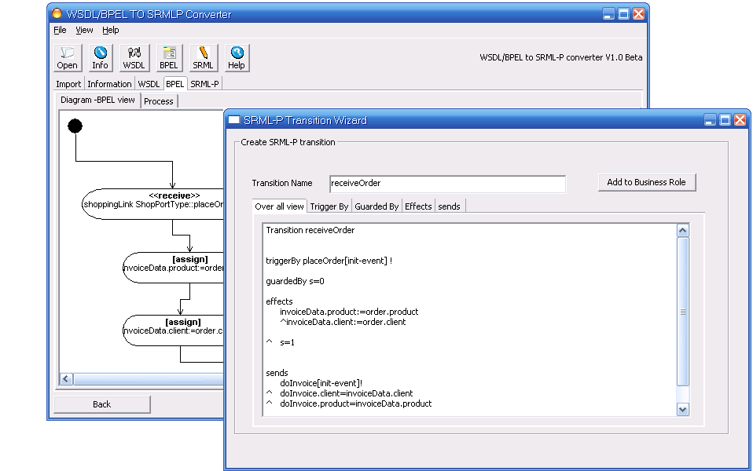
Figure 7.4 SRML-P Orchestration Editor when double click the BPEL activity
SRML-P editor contains five views: over all view, trigger, guard, effect and send where user can edit each section in a SRML-P transition.

Generate SRML-P Business Protocol
In the last chapter, we have already generated SRML-P Business Role. It would be easy to generate Business Protocol base on these codes. Here is a simple example of Business Protocol.

BUSINESS PROTOCOL buyer is
INTERACTIONS
snd placeOrder
out client:Client,product:Product
rcv receiveBill
in bill:Bill
BEHAVIORS
…
Similar to Business Role we generated, Business Protocol consists of INTERACTIONS and BEHAVIOR, This tool is supposed to convert from WSDL document and generate the first section. We just have to put these interactions that required or provided by this co-party. It is almost the same as what we have done in the last chapter. The only difference is the modifier: compare with the one in business role, in and out are swapped.
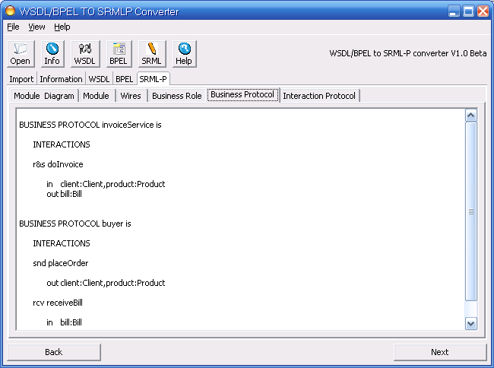
Figure 7.5 Implementation - Business Protocol code generation.

Generate SRML-P Interaction Protocol & Wires
The reason why I put Interaction Protocol and Wires code generation together is they are closely related to each other. Interaction Protocol establishes a relationship between two parties. The interactions in which they are involved are called role A and role B. The following code is a typical Interaction Protocol.
Example: Interaction Protocol and wires

INTERACTION PROTOCOL Straight.I(d1,d2) is
ROLE A
rcv R1
in i1:d1 i2:d2
ROLE B
snd S1
in i1:d1 i2:d2
COORDINATION
R1=S1
R1.i1=S1.i1
R1.i2=S1.i2

This interaction protocol will be used by a SRML-P Wire later.
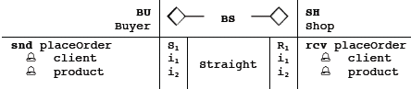
To establish the relationship between two parties, the binding instantiate two roles of the interaction protocol with Buyer and Shop. That is to allow Buyer to send the data to the format expected by the Shop. This table is not easy to be stored as plain text. Thus, the tool will export the table as text in the following format.
BUYER:buyer<>------BUYER_SHOP_LINK------<>SHOP:shop
rcv placeOrder
in client
in product

{R1,i1,i2}
+
| Connected via (Straight)
+
{S1,i1,i2}

snd placeOrder
in client
in product
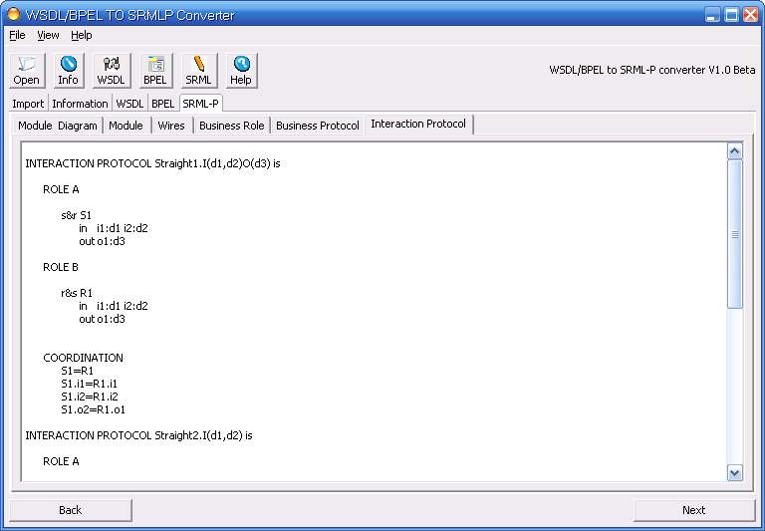
Figure 7.6 Implementation – Interaction Protocol code generation.
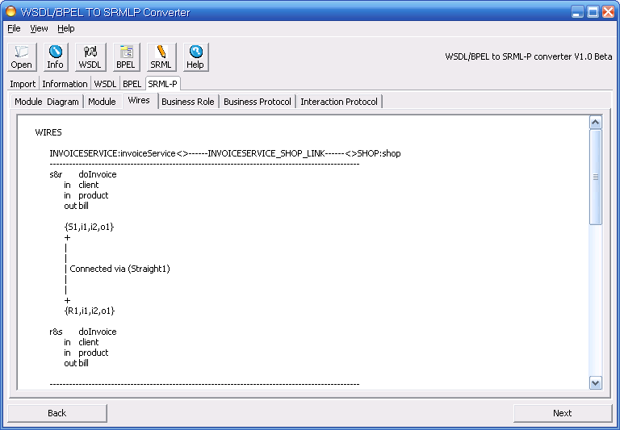
Figure 7.7 Implementation - Wires code generation.

All generated Business Role, Business Protocol, Interaction Protocol and Wires can be exported from File menu.

Testing
Since Eclipse was chosen as developer tool, JUnit, which is a unit test framework for the Java programming language, may well be a good choice for testing the converter. The implementation contains several test cases and can be run from a test suit. Most of the essential methods and constructors are being tested with JUnit. A set of related tests cases can be put in a test suit (AllTest) so that people can execute the all test cases together. Here is how I test method getType of class XMLSchemaType in package sensorial.convert.BPEL.

Example 1: Use JUnit to test getNameSpace() method

package sensoria.convert.BPEL;
import junit.framework.TestCase;

public class TestXMLSchemaType extends TestCase {
XMLSchemaType type;
protected void setUp() throws Exception {
super.setUp();
type=new XMLSchemaType("ns:bill");
//Initial a XMLSchemaType bill with namespace “ns”
}
. . . .
public void testGetNameSpaceType(){
assertEquals(type.getNamespace(),"ns");
//check if method getNameSpace() works properly
}
}

The segment of Java source code above is one test case from class TestXMLSchemaType. An instance of XMLSchemaType was created in the setUp() method for testing. assertEquals() method is used here to compare the actual value and expected result, the program will throw an exception in which case the method contains bugs. That is to say we must ensure that all methods work correctly as expected. The program must be able to pass all these test cases to guarantee the reliability of the whole system.

On the other hand, some WSDL/BPEL documents are use here to check the compatibility. Besides the typical example myBankProcess.bpel, several WSDL/BPEL documents are being used for testing e.g. a single BPEL document with nested switch statement is chosen to test if the tool displayed the right activity diagram, another WSDL document which contains complicate interfaces but without business process is also selected as test sample to check if it generated the right class diagram.

Further Research & Limitation
There are still many limitations and improvements could be made to this tool in the future. For example, in the current version, no all BPEL elements are supported by WSDL/BPEL to SRML-P converter. The tool did not support <while>, <flow>, <pick>, <scope>, <wait> and <compensate> elements. That means this tool may not accurately display the correct workflow in some cases. For example, it can not deal with a loop in the business process. Besides, this tool does not support parallel activities. In addition, the BPEL activity diagram I draw can not automatically re-arrange the layout due to the complexity of the algorithm, there are the main problem and bugs to be fixed and improved .A upgrade version of the software should improve the performance in the future and offer capabilities that currently not supported.

This individual project only focuses on the transformation from WSDL/BPEL to SRML-P. That is to say the transformation is one direction only. The plan is to implement both directions, if possible. Also, the original requirement was to develop an Eclipse plug-in with EMF/GMF framework, as we do not have a complete Meta-model at the beginning of the project, I developed this standalone software without EMF. However, EMF/GEF is a better choice if the metamodel was ready to use before starting implementation. Once the metamodel are imported to EMF framework, it would be easy to store SRML-P as XML-based document. That is what can be done in the future.

Conclusion
This paper represents a preliminary study of language transformation between WSDL/BPEL and SRML-P. It is commonly believed that high-level services modelling languages such as WSDL/BPEL or SRML-P are likely to become increasingly widely deployed. It is also very important to establish a bridge between two services description languages. WSDL/BPEL to SRML-P converter provides functionalities to transform a large portion of services description from WSDL and BPEL to SRML-P. Users will be more inclined to define their own business processes in SRML-P, if they are able to import existing BPEL process to the current project. It will also improve the efficiency of the development in services-oriented system. However, what I have done so far is just the tip of the iceberg of the issue. More research work still needs to be done in the future.

Appendix

WSDL/BPEL document for input -- myBankProcess.bpel
This example is the input file that used by WSDL/BPEL to SRML-P converter. It describes a very simple web service which only contains three roles: shop, buyer and invoice services.

<process name="myBankProcess" xmlns:wsa="http://schemas.xmlsoap.org/ws/2003/03/addressing" xmlns="http://schemas.xmlsoap.org/ws/2003/03/business-process/" xmlns:ns="http://example.com/namespace" targetNamespace="http://example.com/namespace">
<definitions xmlns="http://schemas.xmlsoap.org/wsdl/" xmlns:bpws="http://schemas.xmlsoap.org/ws/2003/03/business-process/" xmlns:plnk="http://schemas.xmlsoap.org/ws/2003/05/partner-link/" xmlns:soap="http://schemas.xmlsoap.org/wsdl/soap/" xmlns:http="http://schemas.xmlsoap.org/wsdl/http/" xmlns:xs="http://www.w3.org/2001/XMLSchema">
<types>
<xs:schema targetNamespace="http://example.com/namespace" xmlns:ns="http://example.com/namespace" xmlns:xs="http://www.w3.org/2001/XMLSchema">
<xs:complexType name="Transfer">
<xs:sequence>
<xs:element name="credit" type="ns:AccountInfo"/>
<xs:element name="debit" type="ns:AccountInfo"/>
</xs:sequence>
</xs:complexType>
<xs:complexType name="AccountInfo">
<xs:sequence>
<xs:element name="AccountInfo.number" type="xs:decimal"/>
<xs:element name="Bank">
<xs:complexType>
<xs:sequence>
<xs:element name="Bank.code" type="xs:decimal"/>
</xs:sequence>
</xs:complexType>
</xs:element>
</xs:sequence>
</xs:complexType>
<xs:complexType name="Bill">
<xs:sequence>
<xs:element name="pays" type="ns:Client"/>
<xs:element name="contains" type="ns:Product" minOccurs="0" maxOccurs="unbounded"/>
<xs:element name="to" type="ns:AccountInfo"/>
<xs:element name="Bill.status" type="xs:string"/>
<xs:element name="Bill.total" type="xs:string"/>
</xs:sequence>
</xs:complexType>
<xs:complexType name="Client">
<xs:sequence>
<xs:element name="Client.name" type="xs:string"/>
</xs:sequence>
</xs:complexType>
<xs:complexType name="Product">
<xs:sequence>
<xs:element name="Product.descr" type="xs:string"/>
<xs:element name="Product.prize" type="xs:string"/>
</xs:sequence>
</xs:complexType>
</xs:schema>
</types>
<message name="placeOrderInput">
<part name="client" type="ns:Client"/>
<part name="product" type="ns:Product"/>
</message>
<message name="doInvoiceInput">
<part name="client" type="ns:Client"/>
<part name="product" type="ns:Product"/>
</message>
<message name="doInvoiceOutput">
<part name="bill" type="ns:Bill"/>
</message>
<message name="receiveBillInput">
<part name="bill" type="ns:Bill"/>
</message>
<!-- portType implemented by the handleOrder process -->
<portType name="ShopPortType">
<operation name="placeOrder">
<input message="ns:placeOrderInput"/>
</operation>
</portType>
<!-- portTypes used by the handleOrder process -->
<portType name="InvoicingPortType">
<operation name="doInvoice">
<input message="ns:doInvoiceInput"/>
<output message="ns:doInvoiceOutput"/>
</operation>
</portType>
<portType name="BuyerPortType">
<operation name="receiveBill">
<input message="ns:receiveBillInput"/>
</operation>
</portType>
</definitions>
<!-- Partner link types -->
<partnerLinkType name="invoicingLinkType">
<role name="invoiceService">
<portType name="ns:InvoicePortType"/>
</role>
</partnerLinkType>
<partnerLinkType name="shoppingLinkType">
<role name="buyer">
<portType name="ns:BuyerPortType"/>
</role>
<role name="shop">
<portType name="ns:ShopPortType"/>
</role>
</partnerLinkType>
<!-- Partner links -->
<partnerLinks>
<partnerLink name="invoicingLink" partnerLinkType="ns:invoicingLinkType" partnerRole="ns:invoiceService"/>
<partnerLink name="shoppingLink" partnerLinkType="ns:shoppingLinkType" myRole="ns:shop" partnerRole="ns:buyer"/>
</partnerLinks>
<!-- Variables -->
<variables>
<variable name="order" messageType="ns:placeOrderInput"/>
<variable name="invoiceData" messageType="ns:doInvoiceInput"/>
<variable name="bill" messageType="ns:receiveBillInput"/>
</variables>
<!-- Structure of the business process -->
<sequence>
<receive name="receiveOrder" partnerLink="ns:shoppingLink" portType="ns:ShopPortType" operation="ns:placeOrder" variable="order" createInstance="yes"/>
<assign>
<copy>
<from variable="order" part="product"/>
<to variable="invoiceData" part="product"/>
</copy>
</assign>
<assign>
<copy>
<from variable="order" part="client"/>
<to variable="invoiceData" part="client"/>
</copy>
</assign>
<invoke name="invokeInvoice" partnerLink="ns:invoicingLink" portType="ns:InvoicePortType" operation="ns:doInvoice" inputVariable="invoiceData" outputVariable="bill"/>
<invoke name="sendBill" partnerLink="ns:shoppingLink" portType="ns:BuyerPortType" operation="ns:receiveBill" variable="bill"/>
</sequence>
</process>

Sample SRML-P output from myBankProcess.bpel
Note: The document is too large to place here, please refer to documentation in directory [/Document] of the CD.

SRML-P Interaction Types and Notations
As mentioned in chapter 8.2, the types of SRML-P event are defined as small icons. In order to present them in a text editor, the program uses alternative textual representation.

Notation | Type of events in SRML-P | Textual representation  in the tool
 | Initiating interaction. | [initial-event]
 | Reply-event of interaction. | [reply-event]
 | Cancel-event of interaction | [cancel-event]
 | Commit-event of interaction | [commit-event]
 | Deadline-event of interaction | [deadline-event]
 | Revoke-event of interaction | [revoke-event]

Term | Type of interactions in SRML-P
r&s | The interaction is initiated by the co-party, which expects a reply. The co-party does not block while waiting for the reply.
s&r | The interaction is initiated by the party and expects a reply from its co-party.  While waiting for the reply, the party does not block.
rcv | The co-party initiates the interaction and does not expect a reply.
snd | The party initiates the interaction and does not expect a reply.
ask | The party synchronises with the co-party to obtain data.
rpl | The party synchronises with the co-party to transmit data.
tll | The party requests the co-party to perform an operation and blocks.
prf | The party performs an operation and frees the co-party that requested it.

SRML-P Metamodel
This metamodel is from ‘The SENSORIA Reference Modelling Language Primitives for Service Descriptio’ [1] Version 1.3. (This version is not a complete and final version)
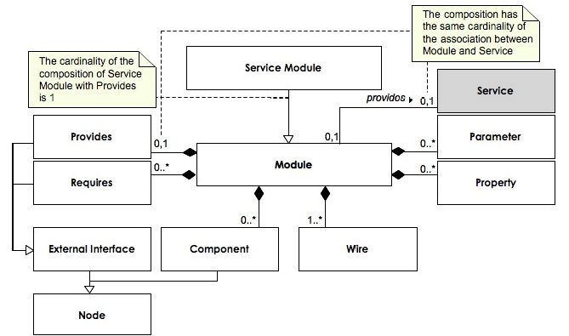
Figure 1 SRML-P Module and Services Module

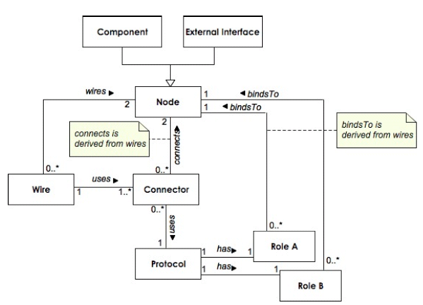
Figure 2 the Wires
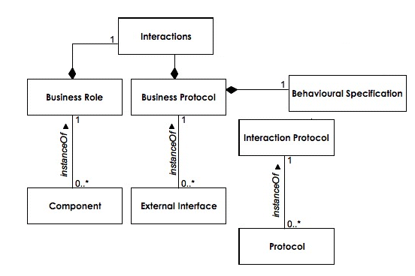
Figure 3 SRML-P Specifications
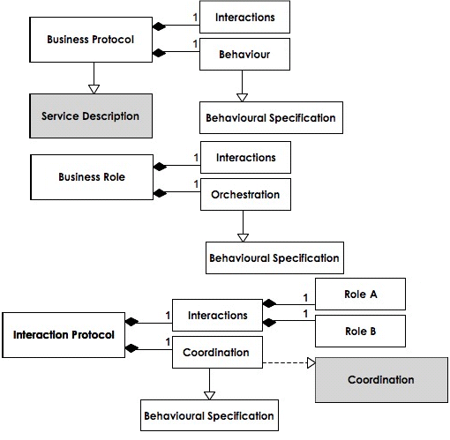
Figure 4 Detail view

Project Plan & Gantt chart
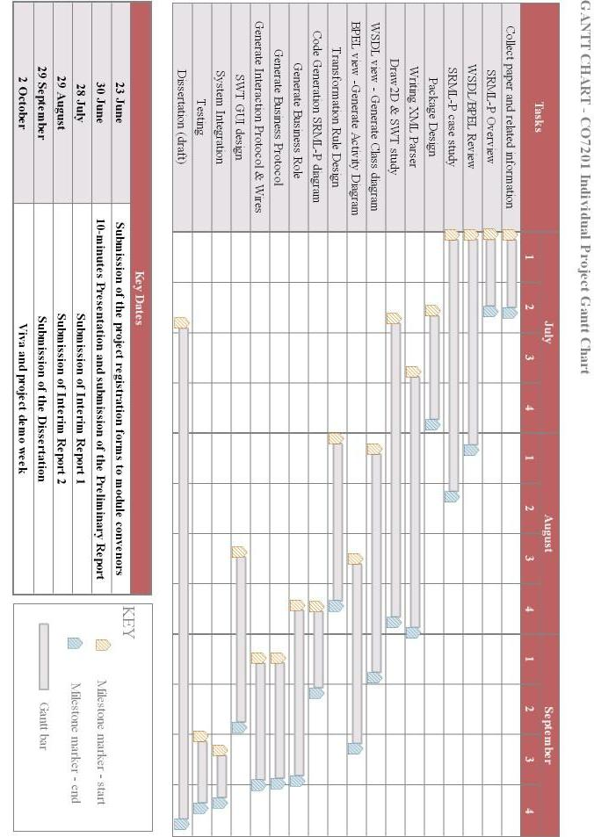

Install Guide
The section describes how to install WSDL/BPEL to SRML-P converter from windows platform.
You can either install the program from self-installing executable, or run directly from .bat file. On Windows, Please copy these all source codes folder from CD, the program can be run by double clicking run.bat. Please make sure that JRE must be 5.0 or higher version.

A user manual is also available on the CD.

Install Steps (Windows Executable File)

Step 1 – Run executable file install.exe
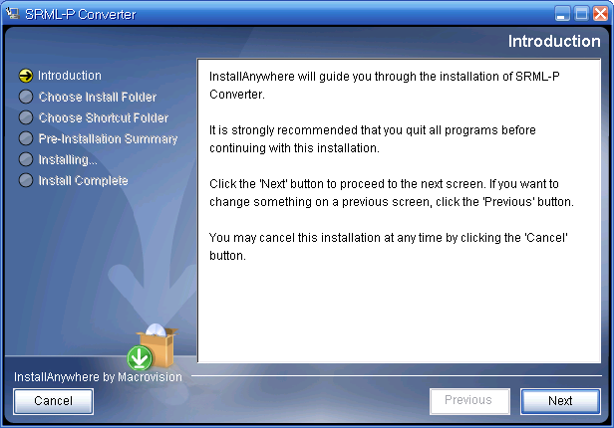

Step 2 – Select the folder to be installed

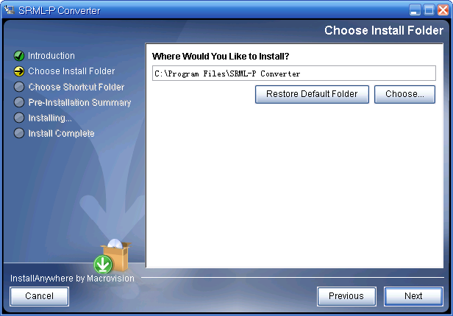

Step 3 Select the program group to be installed

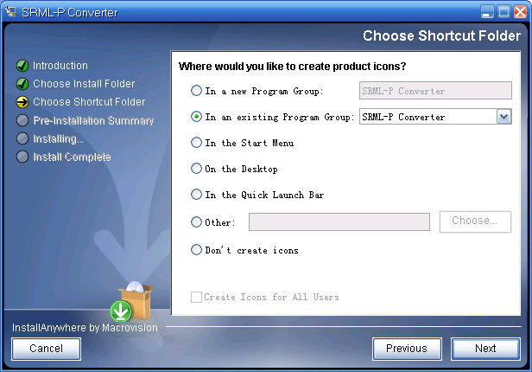

Step 4 Run program from Start Menu ->Programs->SRML-P Converter

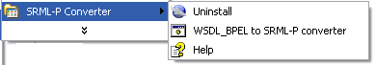

Step 5 A User Guide is also available from the menu.
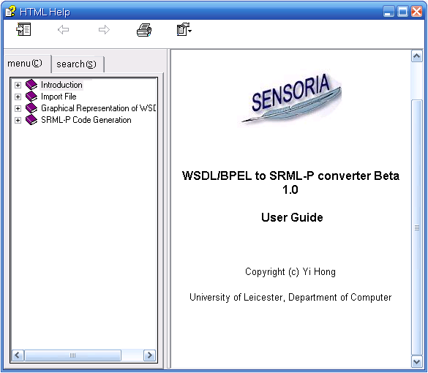

Bibliography
[1] J. L. Fiadeiro, A Lopes, L Bocchi (2006), The SENSORIA Reference Modelling Language
Primitives for Service Description, Draft 1.3, pp 2-14

[2] J. L. Fiadeiro, A Lopes, L Bocchi (2006) A Formal Approach to Service Component Architecture, Draft, pp. 2-8

[3] N. Eric (2002) Understanding Web Services, Addison-Wesley, Boston, pp.81-109

[4] F Budinsky, R. Ellersick, Timothy J. Grose. Eclipse Modeling Framework, Addison-Wesley, Boston, pp 10-25

[5] OASIS, Business Process Execution Language for Web Services (BPEL4WS) Specification Version 1.1 ftp://www6.software.ibm.com/software/developer/library/ws-bpel.pdf

[6] W3C, Web Services Description Language (WSDL) Specification: http://www.w3.org/TR/wsdl

[7] Daniel Lee, 2003, Display a UML Diagram using Draw2D, http://www.eclipse.org/articles/Article-GEF-Draw2d/GEF-Draw2d.html

[8] L Bocchi, My Bank Process with SRML-P, Draft pp.1-4

[9] Ramachandran S (2003). Basic SWT Widgets, University of Manitoba, Canada.

[10] Borland Software Corporation, Borland Together Documentation.

[11] Berry de Vos and Jos Zwiers, Guide to BPEL, http://www.radikalfx.com/bpel/language.html

Apache Xerces parser can be download from http://xml.apache.org/
Since GEF is an open source project, modifications to the GEF codebase could potentially allow a GEF editor without Eclipse.

